FRAMEWORK FOR DATA AND VISUAL ANALYTICS
EXPERIMENT : 1-7
ROLL.NO : 231501151
DEPT : AIML

EXP-1 Setting up the Python environment and libraries-Juypter Notebook
PROGRAM:

print("Hello, Google Colab!")

**Bold Text** and *Italic Text*

- Bullet 1
- Bullet 2

`Inline code` [Google](https://www.google.com)

import ipywidgets as widgets
from IPython.display import display

# Slider example
slider = widgets.IntSlider(value=5, min=0, max=10, step=1, description='Slider:')
display(slider)

# Textbox and button
text = widgets.Text(value='Hello', description='Name:') button = widgets.Button(description='Greet')

def on_button_clicked(b): print(f"Hello, {text.value}!")

button.on_click(on_button_clicked) display(text, button)

OUTPUT:

Hello, Google Colab!

Bold Text and Italic Text
- Bullet 1
- Bullet 2
Inline code
Google
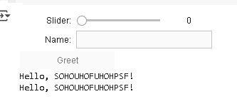
EXP-2 Data Import and Export

PROGRAM:
import pandas as pd

# Replace with your CSV file URL url =
'https://raw.githubusercontent.com/kwaldenphd/eda-pandas/main/data
/titanic.csv'
df_csv = pd.read_csv(url)

# Display the first few rows df_csv.head()

df_excel = pd.read_excel("/content/output.xlsx") # Replace with uploaded file name
print("Excel Data:") print(df_excel.head())

from google.colab import drive drive.mount('/content/drive')

# Create sample SQLite database and table (for demo) engine = create_engine('sqlite://', echo=False) df_sample = pd.DataFrame({
"Name": ["Alice", "Bob", "Charlie"], "Age": [25, 30, 35]
})
df_sample.to_sql("people", con=engine, index=False)

# Read from the SQL table
df_sql = pd.read_sql("SELECT * FROM people", engine) print("SQL Data:")
print(df_sql)

# Read HTML table from a webpage url =
"https://en.wikipedia.org/wiki/List_of_countries_by_GDP_(nominal)" tables = pd.read_html(url)

# Display the first table df_web = tables[0] print("Web Table Data:") print(df_web.head())
import pandas as pd # Sample DataFrame
data = {'Name': ['Alice', 'Bob', 'Charlie'], 'Age': [25, 30, 35],
'City': ['New York', 'San Francisco', 'Los Angeles']} df = pd.DataFrame(data)

# Export to Excel df.to_excel('output1.xlsx', index=False)

OUTPUT:

Passe  ngerId | Surv  ived | Pcl  ass | Na  me | Sex | Ag  e | Sib  Sp | Pa  rch | Tic  ket | Fare | Cab  in | Emba  rked
0 | 1 | 0 | 3 | Braun d, Mr. Owen Harris | mal  e | 22.  0 | 1 | 0 | A/5 21171 | 7.25  00 | NaN | S
1 | 2 | 1 | 1 | Cumi ngs, | fem ale | 38.  0 | 1 | 0 | PC 17599 | 71.2  833 | C85 | C

Passe  ngerId | Surv  ived | Pcl  ass | Na  me | Sex | Ag  e | Sib  Sp | Pa  rch | Tic  ket | Fare | Cab  in | Emba  rked
Mrs.
John
Bradl
ey
(Flore
nce
Brigg
s Th...

2 | 3 | 1 | 3 | Heikk inen, Miss. Laina | fem ale | 26.  0 | 0 | 0 | STO N/O2. 31012  82 | 7.92  50 | NaN | S
3 | 4 | 1 | 1 | Futrel  le, Mrs. Jacqu  es Heath (Lily May Peel) | fem ale | 35.  0 | 1 | 0 | 11380  3 | 53.1  000 | C123 | S
4 | 5 | 0 | 3 | Allen,  Mr. Willia  m Henry | mal  e | 35.  0 | 0 | 0 | 37345  0 | 8.05  00 | NaN | S

Excel Data:
PassengerId Survived Pclass \
0 1 0 3
1 2 1 1
2 3 1 3
3 4 1 1
4 5 0 3

Name Sex Age SibSp \
- Braund, Mr. Owen Harris male 22.0 1
- Cumings, Mrs. John Bradley (Florence Briggs Th... female 38.0 1
- Heikkinen, Miss. Laina female 26.0 0
- Futrelle, Mrs. Jacques Heath (Lily May Peel) female 35.0 1
- Allen, Mr. William Henry male 35.0 0

Parch Ticket Fare Cabin Embarked
0 0 A/5 21171 7.2500 NaN S
1 0 PC 17599 71.2833 C85 C
2 0 STON/O2. 3101282 7.9250 NaN S

3 | 0 | 113803 53.1000 C123 | S
4 | 0 | 373450 8.0500 NaN | S
addCode addText
Drive already mounted at /content/drive; to attempt to forcibly remount, call drive.mount("/content/drive", force_remount=True).
addCode addText

SQL Data:
Name Age
- Alice 25
- Bob 30
Web Table Data:
0
0 Largest economies in the world by GDP (nominal...
2 Charlie 35

EXP-3 Data Cleaning

PROGRAM:
import pandas as pd import numpy as np
from sklearn.preprocessing import StandardScaler, MinMaxScaler

# Sample dataset creation (you can replace this with your own dataset)
data = {
'Name': ['Alice', 'Bob', 'Charlie', 'David', 'Edward', 'Alice'],
'Age': [25, np.nan, 30, 22, 35, 25],
'Salary': [50000, 60000, np.nan, 52000, 58000, 50000],
'Department': ['HR', 'IT', 'IT', np.nan, 'Finance', 'HR'],
'JoinDate': ['2010-01-10', '2012-05-15', '2011-08-20',
'2013-07-30', '2010-11-25', '2010-01-10']
}

df = pd.DataFrame(data) print("Original DataFrame:") print(df)

print("\nMissing values in each column:") print(df.isnull().sum())

print("\nMissing values in each column:") print(df.isnull().sum())

df.dropna(subset=['Salary'], inplace=True) df.drop_duplicates(inplace=True) df.drop(columns=['JoinDate'], inplace=True)
df['Age'] = df['Age'].astype(int) df['Salary'] = df['Salary'].astype(int)
df['Department'] = df['Department'].astype('category') scaler = StandardScaler()
df[['Age', 'Salary']] = scaler.fit_transform(df[['Age', 'Salary']])
print("\nAfter Standardization:") print(df[['Age', 'Salary']])

minmax_scaler = MinMaxScaler()
df[['Age', 'Salary']] = minmax_scaler.fit_transform(df[['Age', 'Salary']])
print("\nAfter Min-Max Scaling:") print(df[['Age', 'Salary']])
OUTPUT:

Original DataFrame:
Name Age Salary Department JoinDate
0 Alice 25.0 50000.0 HR 2010-01-10
1 Bob NaN 60000.0 IT 2012-05-15
2 Charlie 30.0 NaN IT 2011-08-20
3 David 22.0 52000.0 NaN 2013-07-30
4 Edward 35.0 58000.0 Finance 2010-11-25
5 Alice 25.0 50000.0 HR 2010-01-10
Missing values in each column:
Name 0
Age 1
Salary 1
Department 1
JoinDate 0
dtype: int64
/tmp/ipython-input-4-2707674413.py:1: FutureWarning: A value is trying to be set on a copy of a DataFrame or Series through chained assignment using an inplace method.
The behavior will change in pandas 3.0. This inplace method will never work because the intermediate object on which we are setting values always behaves as a copy.

For example, when doing 'df[col].method(value, inplace=True)', try using 'df.method({col: value}, inplace=True)' or df[col] = df[col].method(value) instead, to perform the operation inplace on the original object.

df['Age'].fillna(df['Age'].mean(), inplace=True)
/tmp/ipython-input-4-2707674413.py:2: FutureWarning: A value is trying to be set on a copy of a DataFrame or Series through chained assignment using an inplace method.
The behavior will change in pandas 3.0. This inplace method will never work because the intermediate object on which we are setting values always behaves as a copy.

For example, when doing 'df[col].method(value, inplace=True)', try using 'df.method({col: value}, inplace=True)' or df[col] = df[col].method(value) instead, to perform the operation inplace on the original object.

df['Department'].fillna(df['Department'].mode()[0], inplace=True)
After Standardization: Age Salary
0 -0.467257 -1.212678
1 -0.051917 1.212678
3 -1.090266 -0.727607
4 1.609440 0.727607

After Min-Max Scaling: Age Salary
0 0.230769 | 0.0
1 0.384615 | 1.0
3 0.000000 | 0.2
4 1.000000 | 0.8

EXP-4 -Data Inspection and Analysis

PROGRAM:
import pandas as pd import numpy as np
from sklearn.datasets import load_iris

# Load the Iris dataset from sklearn iris = load_iris()
df = pd.DataFrame(data=iris.data, columns=iris.feature_names) # Add the species column
df['species'] = pd.Categorical.from_codes(iris.target, iris.target_names) df.head() # View first 5 rows
df.tail() # View last 5 rows
df.info() # Summary: data types, nulls df.describe() # Quick stats for numerical columns df.columns #colummn names
df.shape # Rows and columns count

df[df['species'] == 'setosa']

df[(df['species'] == 'setosa') & (df['sepal length (cm)'] > 5.0)] df[['sepal length (cm)', 'sepal width (cm)']]

df['sepal length (cm)'].mean() # Mean df['sepal length (cm)'].median() # Median
df['sepal length (cm)'].mode() # Mode (returns a Series) df['sepal length (cm)'].min(), df['sepal length (cm)'].max() # Range df['sepal length (cm)'].var() # Variance
df['sepal length (cm)'].std() # Standard Deviation df.corr(numeric_only=True)

OUTPUT:

<class 'pandas.core.frame.DataFrame'> RangeIndex: 150 entries, 0 to 149
Data columns (total 4 columns):
# Column Non-Null Count Dtype

0 sepal length (cm) | 150 non-null | float64
1 sepal width (cm) | 150 non-null | float64
2 petal length (cm) | 150 non-null | float64
3 petal width (cm) | 150 non-null | float64
dtypes: float64(4) memory usage: 4.8 KB (150, 4)

 | sepal length  (cm) | sepal width  (cm) | petal length  (cm) | petal width  (cm) | specie  s
0 | 5.1 | 3.5 | 1.4 | 0.2 | setosa
1 | 4.9 | 3.0 | 1.4 | 0.2 | setosa
2 | 4.7 | 3.2 | 1.3 | 0.2 | setosa
3 | 4.6 | 3.1 | 1.5 | 0.2 | setosa
4 | 5.0 | 3.6 | 1.4 | 0.2 | setosa
5 | 5.4 | 3.9 | 1.7 | 0.4 | setosa
6 | 4.6 | 3.4 | 1.4 | 0.3 | setosa
7 | 5.0 | 3.4 | 1.5 | 0.2 | setosa
8 | 4.4 | 2.9 | 1.4 | 0.2 | setosa
9 | 4.9 | 3.1 | 1.5 | 0.1 | setosa
10 | 5.4 | 3.7 | 1.5 | 0.2 | setosa
11 | 4.8 | 3.4 | 1.6 | 0.2 | setosa
12 | 4.8 | 3.0 | 1.4 | 0.1 | setosa
13 | 4.3 | 3.0 | 1.1 | 0.1 | setosa
14 | 5.8 | 4.0 | 1.2 | 0.2 | setosa

sepal length (cm)
sepal width (cm)
petal length (cm)
petal width (cm)
specie s

15 | 5.7 | 4.4 | 1.5 | 0.4 | setosa
16 | 5.4 | 3.9 | 1.3 | 0.4 | setosa
17 | 5.1 | 3.5 | 1.4 | 0.3 | setosa
18 | 5.7 | 3.8 | 1.7 | 0.3 | setosa
19 | 5.1 | 3.8 | 1.5 | 0.3 | setosa
20 | 5.4 | 3.4 | 1.7 | 0.2 | setosa
21 | 5.1 | 3.7 | 1.5 | 0.4 | setosa
22 | 4.6 | 3.6 | 1.0 | 0.2 | setosa
23 | 5.1 | 3.3 | 1.7 | 0.5 | setosa
24 | 4.8 | 3.4 | 1.9 | 0.2 | setosa
25 | 5.0 | 3.0 | 1.6 | 0.2 | setosa
26 | 5.0 | 3.4 | 1.6 | 0.4 | setosa
27 | 5.2 | 3.5 | 1.5 | 0.2 | setosa
28 | 5.2 | 3.4 | 1.4 | 0.2 | setosa
29 | 4.7 | 3.2 | 1.6 | 0.2 | setosa

sepal length (cm)
sepal width (cm)
petal length (cm)
petal width (cm)
specie s

30 | 4.8 | 3.1 | 1.6 | 0.2 | setosa
31 | 5.4 | 3.4 | 1.5 | 0.4 | setosa
32 | 5.2 | 4.1 | 1.5 | 0.1 | setosa
33 | 5.5 | 4.2 | 1.4 | 0.2 | setosa
34 | 4.9 | 3.1 | 1.5 | 0.2 | setosa
35 | 5.0 | 3.2 | 1.2 | 0.2 | setosa
36 | 5.5 | 3.5 | 1.3 | 0.2 | setosa
37 | 4.9 | 3.6 | 1.4 | 0.1 | setosa
38 | 4.4 | 3.0 | 1.3 | 0.2 | setosa
39 | 5.1 | 3.4 | 1.5 | 0.2 | setosa
40 | 5.0 | 3.5 | 1.3 | 0.3 | setosa
41 | 4.5 | 2.3 | 1.3 | 0.3 | setosa
42 | 4.4 | 3.2 | 1.3 | 0.2 | setosa
43 | 5.0 | 3.5 | 1.6 | 0.6 | setosa
44 | 5.1 | 3.8 | 1.9 | 0.4 | setosa

sepal length (cm)
sepal width (cm)
petal length (cm)
petal width (cm)
specie s

45 | 4.8 | 3.0 | 1.4 | 0.3 | setosa
46 | 5.1 | 3.8 | 1.6 | 0.2 | setosa
47 | 4.6 | 3.2 | 1.4 | 0.2 | setosa
48 | 5.3 | 3.7 | 1.5 | 0.2 | setosa
49 | 5.0 | 3.3 | 1.4 | 0.2 | setosa

sepal length (cm) sepal width (cm) petal length (cm) petal width (cm) species

0 | 5.1 | 3.5 | 1.4 | 0.2 | setosa
5 | 5.4 | 3.9 | 1.7 | 0.4 | setosa
10 | 5.4 | 3.7 | 1.5 | 0.2 | setosa
14 | 5.8 | 4.0 | 1.2 | 0.2 | setosa
15 | 5.7 | 4.4 | 1.5 | 0.4 | setosa
16 | 5.4 | 3.9 | 1.3 | 0.4 | setosa
17 | 5.1 | 3.5 | 1.4 | 0.3 | setosa
18 | 5.7 | 3.8 | 1.7 | 0.3 | setosa
19 | 5.1 | 3.8 | 1.5 | 0.3 | setosa
20 | 5.4 | 3.4 | 1.7 | 0.2 | setosa
21 | 5.1 | 3.7 | 1.5 | 0.4 | setosa
23 | 5.1 | 3.3 | 1.7 | 0.5 | setosa

27 | 5.2 | 3.5 | 1.5 | 0.2 | setosa
28 | 5.2 | 3.4 | 1.4 | 0.2 | setosa
31 | 5.4 | 3.4 | 1.5 | 0.4 | setosa
32 | 5.2 | 4.1 | 1.5 | 0.1 | setosa
33 | 5.5 | 4.2 | 1.4 | 0.2 | setosa
36 | 5.5 | 3.5 | 1.3 | 0.2 | setosa
39 | 5.1 | 3.4 | 1.5 | 0.2 | setosa
44 | 5.1 | 3.8 | 1.9 | 0.4 | setosa
46 | 5.1 | 3.8 | 1.6 | 0.2 | setosa
48 | 5.3 | 3.7 | 1.5 | 0.2 | setosa

sepal length (cm) | sepal width (cm)
0 | 5.1 | 3.5
1 | 4.9 | 3.0
2 | 4.7 | 3.2
3 | 4.6 | 3.1
4 | 5.0 | 3.6
... | ... | ...
145 | 6.7 | 3.0

sepal width (cm)
sepal length (cm)

146 | 6.3 | 2.5
147 | 6.5 | 3.0
148 | 6.2 | 3.4
149 | 5.9 | 3.0

150 rows × 2 columns

sepal length (cm)
0 | 5.0

dtype: float64

0.8280661279778629
sepal length (cm) sepal width (cm) petal length (cm) petal width (cm)

sepal length (cm) | 1.000000 | -0.117570 | 0.871754 | 0.817941
sepal width (cm) | -0.117570 | 1.000000 | -0.428440 | -0.366126
petal length (cm) | 0.871754 | -0.428440 | 1.000000 | 0.962865
petal width (cm) | 0.817941 | -0.366126 | 0.962865 | 1.000000

EXP-5 Data Visualization with matplotlib

PROGRAM:
# EDA - Data Visualization with Matplotlib

# Install matplotlib if not already (usually preinstalled in Colab) # !pip install matplotlib

import matplotlib.pyplot as plt import numpy as np

# Sample data

x = np.arange(1, 11)

y = np.random.randint(10, 100, size=10) categories = ['A', 'B', 'C', 'D', 'E'] values = [23, 45, 56, 78, 33]
hist_data = np.random.randn(1000) # Normal distribution # 1. Line Chart
plt.figure(figsize=(8, 4))

plt.plot(x, y, marker='o', linestyle='-', color='blue') plt.title('Line Chart Example')
plt.xlabel('X-axis') plt.ylabel('Y-axis') plt.grid(True) plt.show()

# 2. Bar Chart plt.figure(figsize=(8, 4))
plt.bar(categories, values, color='green') plt.title('Bar Chart Example') plt.xlabel('Categories')
plt.ylabel('Values') plt.show()

# 3. Histogram

plt.figure(figsize=(8, 4))

plt.hist(hist_data, bins=20, color='purple', edgecolor='black') plt.title('Histogram Example')
plt.xlabel('Value') plt.ylabel('Frequency') plt.show()
OUTPUT
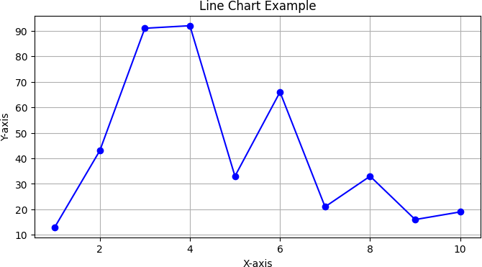

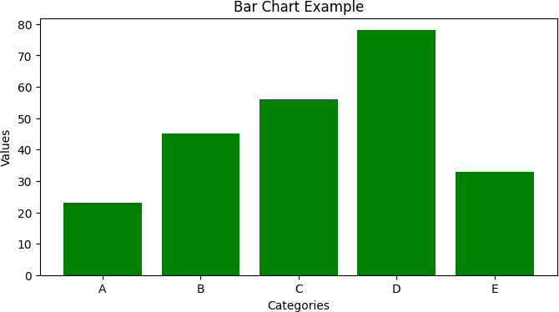
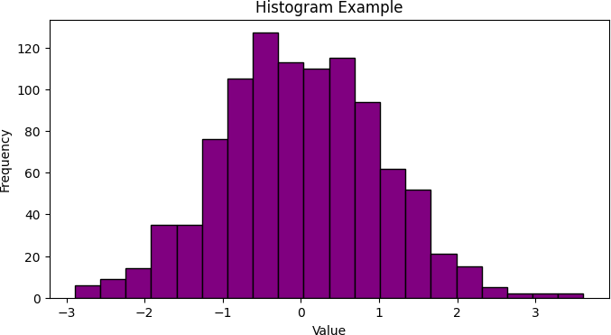

EXP-6 Data visualization Using PowerBi

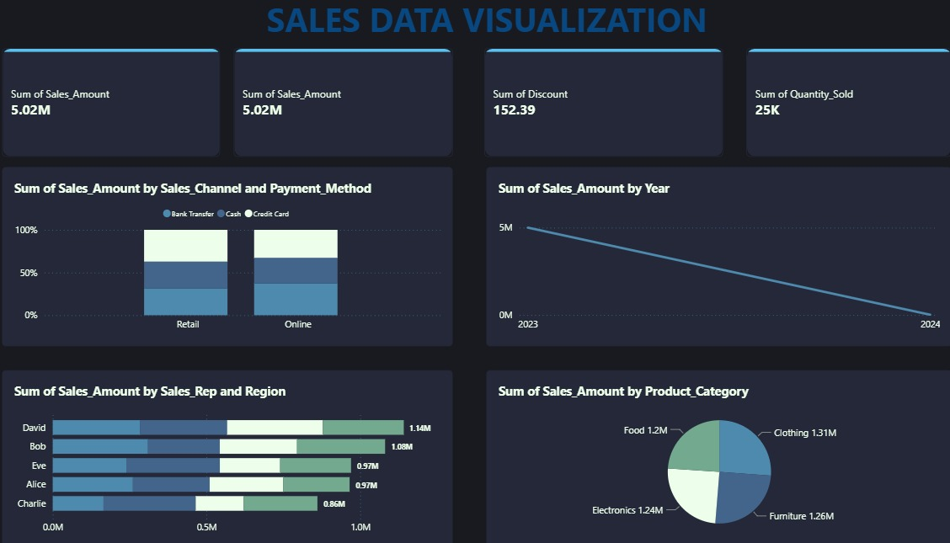

EXP-7 Data Visualization Using Tableau

